# SUMMER TRAINING REPORT ON

**Food Blogs Website**

**(HTML and Bootstrap)**

SUBMITTED IN PARTIAL FULFILLMENT OF THE REQUIREMENT FOR THE AWARD

OF THE DEGREE OF

# BACHELOROF ENGINEERING

**(Computer Science & Engineering)**

**Submitted by:**

**Joy deb**

**19BCS2264**



**CHANDIGARHUNIVERSITY,GHARUAN ,MOHALI-140413,PUNJAB**

### December, 2020

**Project Title**

This is to certify that the Joy deb has successfully completed the project work title “**Food Blogs Website**” submitted in the partial fulfillment for the award of the degree of **BACHELOR OF** E**NGINEERING in Computer Science and Engineering.**

This project is the record of authentic work carried out during the academic year 2019-2023.

**DECLARATION**

I the undersigned solemnly declare that the project report is based on my own work carried out during the course of our study. I assert the statements made and conclusions drawn are an outcome of my work. I further certify that the work contained in the report is original and has been done by me under the general supervision of my supervisor.

1. The work has not been submitted to any other Institution for any other degree/diploma/certificate in this university or any other University of India or abroad.
2. We have followed the guidelines provided by the university in writing the report.
3. Whenever we have used materials (data, theoretical analysis, and text) from other sources, we have given due credit to them in the text of the report and giving their details in the references.

Name :Joy deb

UID :19BCS22264

# ACKNOWLEDGEMENT

I have taken efforts in this project. However, it would not have been possible without the kind support and help of many individuals and organizations. I would like to extend my sincere thanks to all of them.

I am highly indebted to (Name of your Organization Guide) for their guidance and constant supervision as well as for providing necessary information regarding the project & also for their support in completing the project.

I would like to express my gratitude towards my parents and my department for their kind co- operation and encouragement which help me in completion of this project.

THANKS AGAIN TO ALL WHO HELPED

# CONTENT

## Chapter 1: Introduction

Chapter2: Training work undertaken Chapter3: Results and Discussion Chapter 4: Conclusion and Future Scope

### INTRODUCTION:

* 1. **Introdution to Bootstrap**

This module gives you a quick introduction to full-stack web development and the outline of the course. Then you will learn the basics of Bootstrap, setting up a web project using Bootstrap. You will learn about responsive design and the Bootstrap grid system. At the end of this module, you need to complete your first assignment.

### Bootstrap CSS Component

.This module concentrates on Bootstrap's components that are designed using pure CSS classes. You will learn about Navigation and Navigation bar. Then, you will learn about buttons, forms, tables, cards, images and media, tags, alerts and progress bars. At the end of this module you need to complete your second assignment.n.

### Bootstrap JavaScript Component

This module concentrates on Bootstrap's JavaScript based components. You will learn about tabs, pills and tabbed navigation, collapse, accordion, scrollspy, affix, tooltips, popovers, modals and the carousel. At the end of this module you need to complete the third assignment.

### Web Tools

This module rounds out our discussions on Bootstrap JavaScript components. Then we discuss CSS preprocessors, Less and Sass. Finally, we discuss building and deployment of our Web projects through task automation using NPM scripts, and task runners like Grunt and Gulp. The final assignment of this course needs to be completed at the end of this module.

### Week One (HTML Course)

This week we will uncover the "mystery" behind the Internet. What happens when you type a URL into your browser so that a webpage magically appears? What is HTML5 and what happened to HTML 1 - 4? We will also cover some practical concepts that you need to master before you begin coding your own pages.

### Week Two

This week you will need to take a deep breath and jump into coding. I will cover a large number of HTML tags, but it is important that you do more than just listen to these video and read the text book material. You need to practice (and fail!) in order to learn. Believe it or not, once you master the basic idea of using tags and attributes you will know everything you need to use any HTML5 tag. The page may not look the way you want it to look yet, but you will be able to use text, links, images, tables, and even music and videos! If you want to refer to a textbook this week for reinforcement of concepts, we will be using the Shay Howe online textbook as a reference. I will include links after the lectures, but some students prefer to read before the videos. (My preferred approach is to read/watch/read again.)

### Week Three

Okay, you created a file...what now? This week we will begin by covering the important but often overlooked concepts of validation and accessibility. Did you follow the DOM structure when you created your page? Did you use semantic tags to make sure that page viewers can access all of the information, even if they have physical or cognitive disabilities? This is knowledge you can use if you would like to pursue a career as a web accessibility specialist. Finally I will briefly cover the steps needed to post your site to the web. There are many free and paid services that you can use to get your work off your computer and on to the Internet.

### Food Blog

**Chapter 2:Training work undertaken**

I have done my training on HTML5 and Bootstrap so I have prepared my project on Food Vlog using HTML and Bootstrao

The Project is based upon Food Vlogs where you can search about food using a search box tool by entering the food name and food code . Their is a food catalog section where you will find some of the food menu with the food image and description and will get an about me section where their is info about the company and website and a tell me about yourself section

### PROJECT REQUIREMENTS:

Software Requirements:

* HTML5 and Bootstrap 5

Hardware Requirements:

* + - Operating system: Linux- Ubuntu 16.04 to 17.10, or Windows 7 to 10, with 2GB RAM (4GB preferable)
    - 2. You have to install Virtual Studio Code and related packages, please follow the installation instructions given below as per your operating system.

### IMPLEMENTATION DETAILS

Implemeted using HTML5 and Bootstrap

# CODE

<!DOCTYPE html>

<html lang="en">

<title>Food vlogs</title>

<head>

    <meta charset="UTF-8">

    <title>Document</title>

    <link href="https://fonts.googleapis.com/css?family=Montserrat" rel="stylesheet">

    <link rel="stylesheet" href="normalize.css">

    <link rel="stylesheet" href="custom.css">

</head>

<body>

    <section class="hero_image">

        <div class="hero_wrapper">

            <h1>THE FOOD YOU LOVE</h1>

            <p>Welcome To Food Vlogs Website . Here you will find Different types of Food and Their Details !</p>

            <form class="form_code">

                <input class="post_code" type="text" placeholder="Enter the Food name or Food Code here ">

                <button type="submit">Find Food</button>

            </form>

        </div>

    </section>

    <section class="product">

        <div class="product__list__item">

            <img class="img-responsive" src="food1.jpg" alt="">

            <h2 class="product_heading">

                Rajma Chawal

            </h2>

            <p>Rajma chawal is kidney beans served with boiled rice. Some of the best Rajma is said to be grown in the north Indian state of Himachal Pradesh, Uttarakhand</p>

        </div>

        <div class="product__list__item">

            <img class="img-responsive" src="food2.jpg" alt="">

            <h2 class="product_heading">

                Mutter Panner

            </h2>

            <p>Mutter means peas, and paneer is a solid cottage cheese, so this mutter paneer dish combines the two in a rich tomato-based gravy with a touch of cream.</p>

        </div>

        <div class="product__list__item">

            <img class="img-responsive" src="food3.jpg" alt="">

            <h2 class="product_heading">

                Aloo Parantha

            </h2>

            <p>Looking a lot like a pancake, aaloo paratha is actually a flatbread stuffed with a richly seasoned mashed potato.</p>

        </div>

        <div class="product__list__item">

            <img class="img-responsive" src="food4.jpg" alt="">

            <h2 class="product_heading">

                Hara Bhara Kabab

            </h2>

            <p>you can make a kabab from pieces of fresh vegetables, but this vegetarian kabab is so much more satisfying. In Indian cuisine, kababs are a wide variety of grilled meat, some that are mixtures of ground meat and seasonings. </p>

        </div>

        <div class="product__list__item">

            <img class="img-responsive" src="food5.jpg" alt="">

            <h2 class="product_heading">

                Masala Chai

            </h2>

            <p>There’s nothing like the experience of stopping at a chaiwala on an Indian street and ordering a steaming cup of masala chai. The beverage has gained worldwide popularity, becoming a feature in many coffee and teahouses.</p>

        </div>

        <div class="product__list__item">

            <img class="img-responsive" src="food6.jpg" alt="">

            <h2 class="product_heading">

                Samosas

            </h2>

            <p>Samosas are a very popular traditional Indian Dish. Probably because samosas are a tasty, fried, or baked pastry with savory fillings.</p>

        </div>

        <div class="product__list__item">

            <img class="img-responsive" src="food7.jpg" alt="">

            <h2 class="product_heading">

                Lassi’s

            </h2>

            <p>Lassi’s are yogurt-based drinks made with water, spices, and sometimes fruit. Mango or cardamom-flavored lassis are some of the most popular</p>

        </div>

    </section>

### Intro

**CHAPTER 4: RESULTS AND DISCUSSIONS**

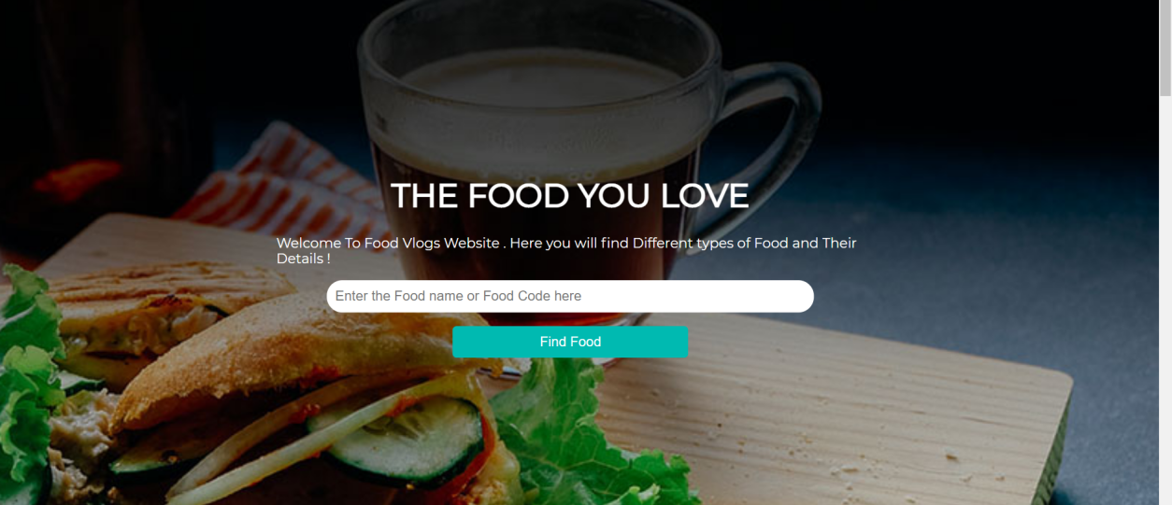

1. **Catalog and Recent Post**

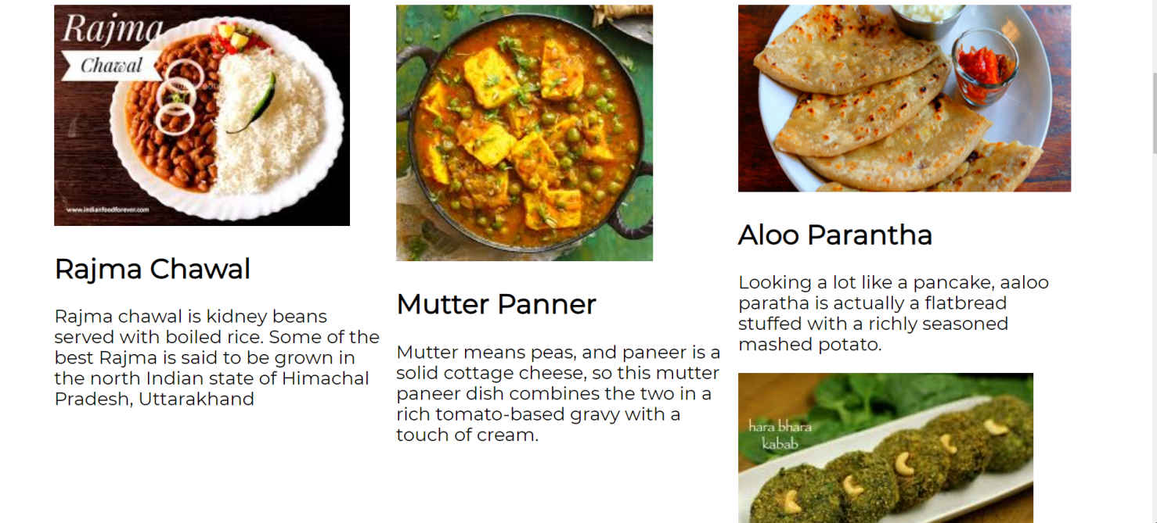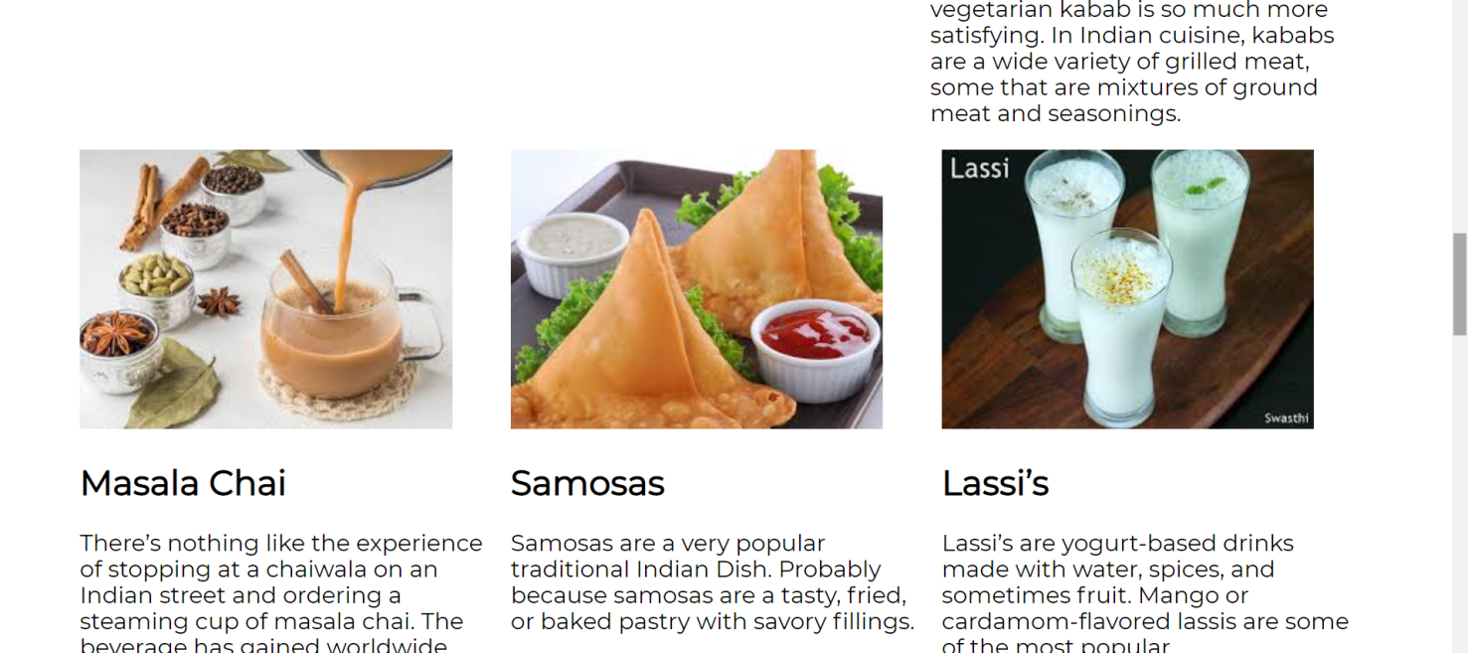

1. **Tell me about yourself**

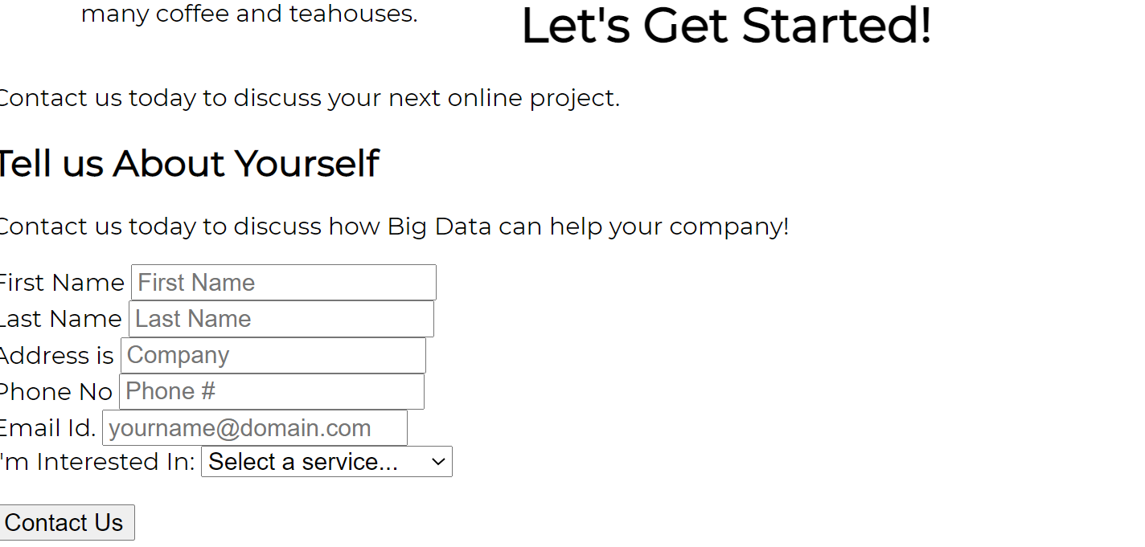

1. **info**

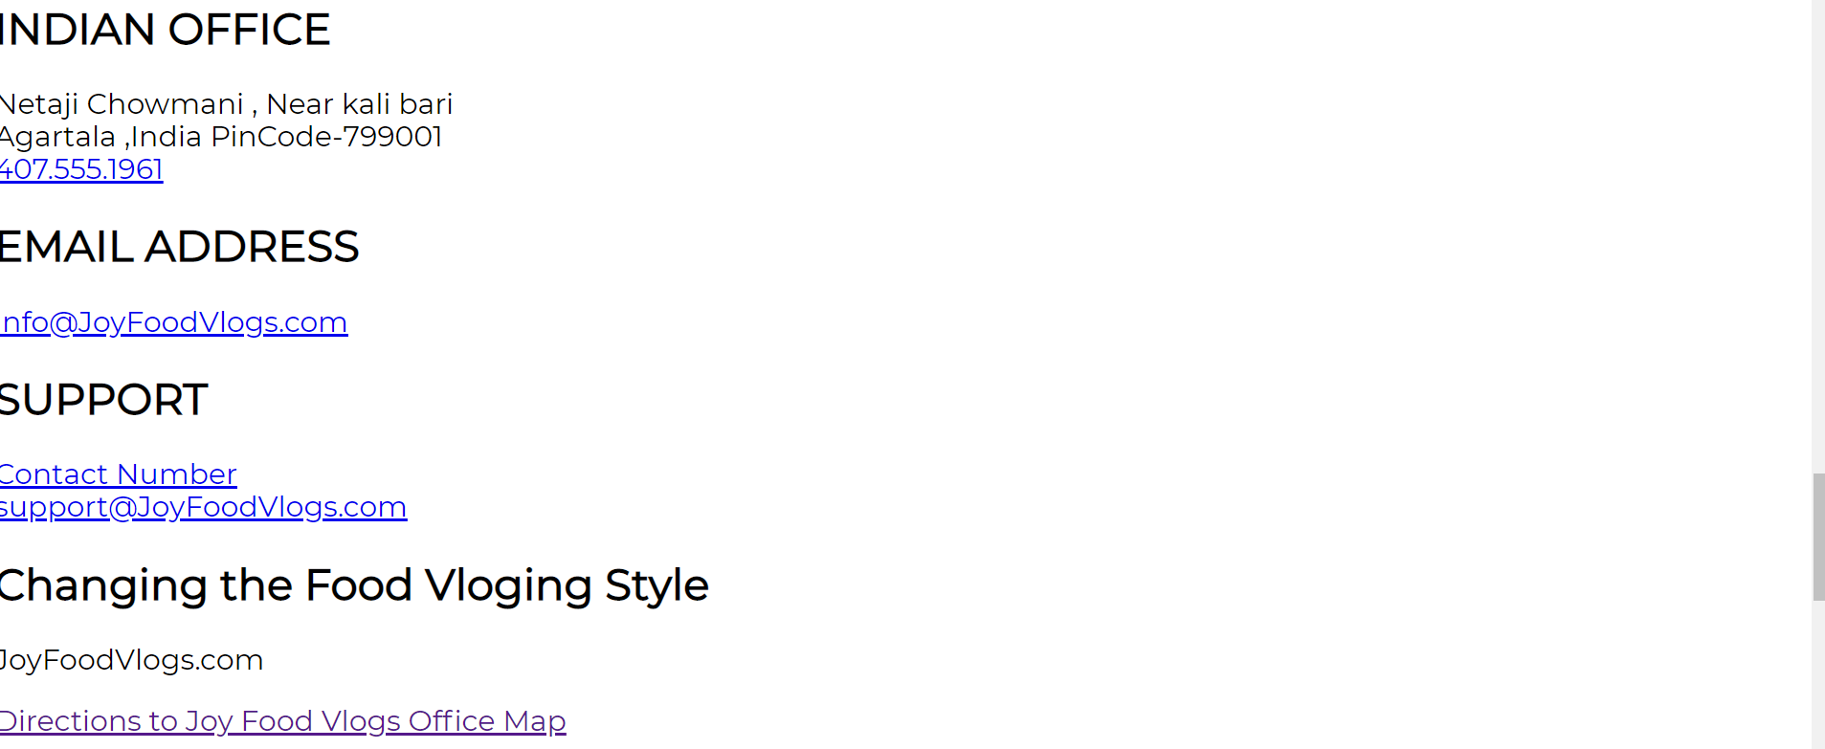

**Chapter 4: Conclusion and Future Scope**

The reason why HTML5 is the future has become quite clear. More people are now accessing the internet via mobile devices when compared to those using desktops. It is important for all businesses to ensure that their websites are responsive to these widely used devices because of this simple yet important reason. However, different types of mobile devices and multiple operating systems increase the challenges for providing support across platforms.

Bootstrap 4 is the newest version of it. It is used for building web UIs. It encompasses a free collection of tools that can be used for building websites and web applications. Including a lot of templates and classes for typography, forms, buttons, navigation and other interface components, it also has optional JavaScript extensions.

ONLINE CERTIFICATE

